|  |  |
| --- | --- |
| **Ex No: 2** | Programs using decision-making constructs. |

**AIM**

Write a C program to find the biggest of two numbers using decision-making constructs.

**PRE-LAB QUESTIONS**

1. What are the relational operators?
2. Write four different C statements, each adding 1 to integer variable A
3. Write the C program to find the area and circumference of a circle of radius ‘r’.
4. Write the C program to convert the temperature from Celsius to Fahrenheit $$F=\frac{5}{9}C+32$$
5. Mention the various conversion specifications for data I/O in C

**ALGORITHM**

**Step 1:** Start  
**Step 2:**  Read two numbers A and B  
**Step 3:** If A > B, print A  
**Step 4:**  Else, print B  
**Step 5:** End

**FLOWCHART**

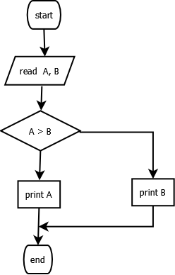

**PROGRAM**

#include<stdio.h>

void main**(){**

int A**,** B**;**

scanf**(**"%d %d"**,** **&**A**,** **&**B**);**

**if** **(**A **>** B**)**

**{**

printf**(**"%d"**,** A**);**

**}**

**else**

**{**

printf**(**"%d"**,** B**);**

**}**

**}**

**INPUTS**

**10 20**

**OUTPUT**

**20**

**POST-LAB QUESTIONS**

1. Write the C program to find the biggest of three numbers
2. Write the C program to evaluate the following expression $$Y=\left\{\begin{aligned}1+x when n=1 \\ 1+\frac{x}{n} when n=2 \\ 1+x^{n }when n=3 \\ 1 +nx when n>3 or n<1\end{aligned}\right.$$
3. What is the value of A, after the following statement is evaluated  
    A = 5 <= 8 && 6 !=5
4. Describe the various I/O functions in C?
5. Explain briefly, the formatted and unformatted I/O functions in C

**RESULT**

Thus sample C programs using decision making constructs has been written, executed and verified successfully.